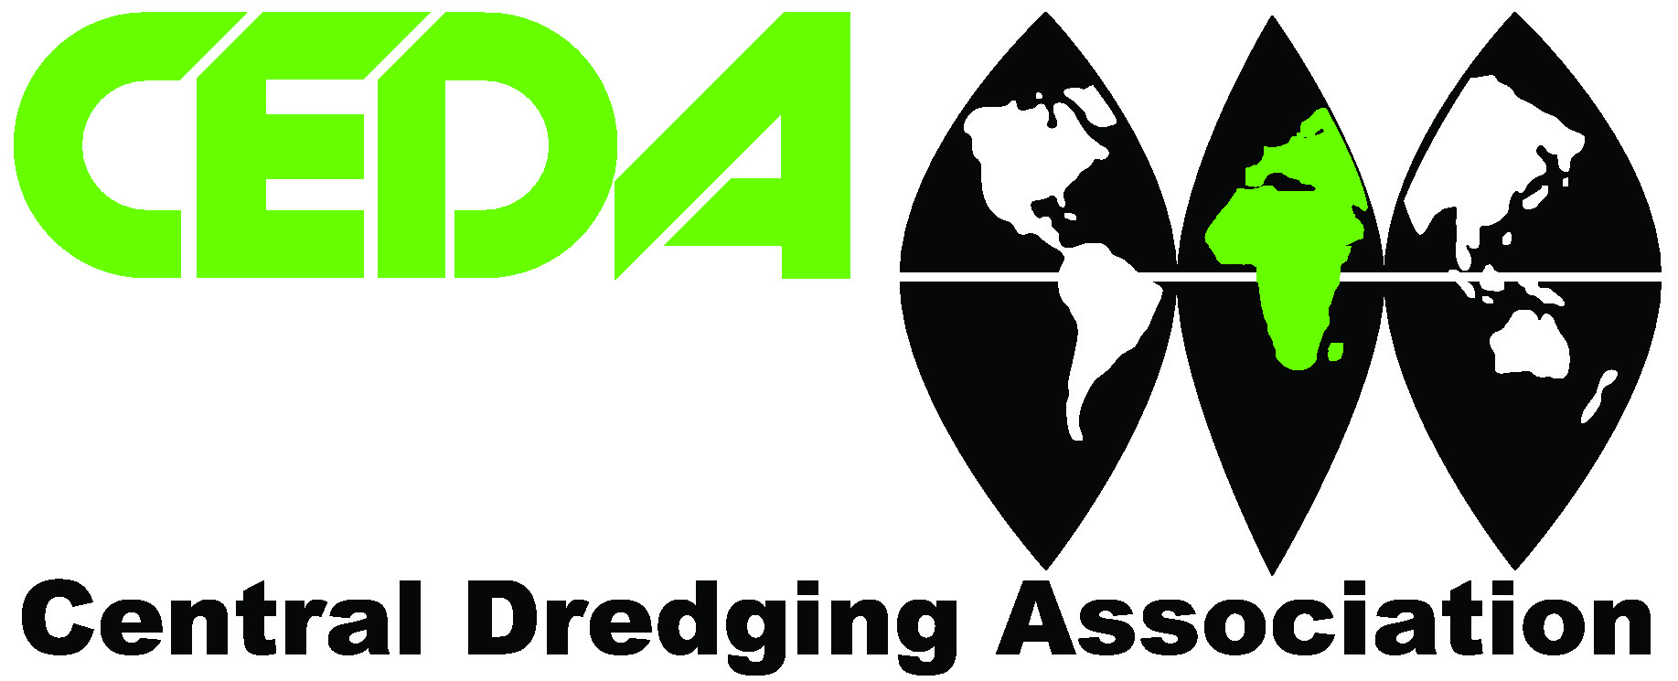

A CEDA conference on dredging and land reclamation

Dredging and Sustainability: How wide is the Gulf?

6th - 7th May 2008
Qatar International Exhibition Centre, Doha, Qatar
In conjunction with Ship & Port + Europort Maritime
5th - 7th May 2008

Under the patronage of and welcome address from the
Sheikh Hamad bin Suhaim al Thani, Minister of State, Government of Qatar.

Keynote addresses from
Speakers from Qatar Petroleum and Naqilat

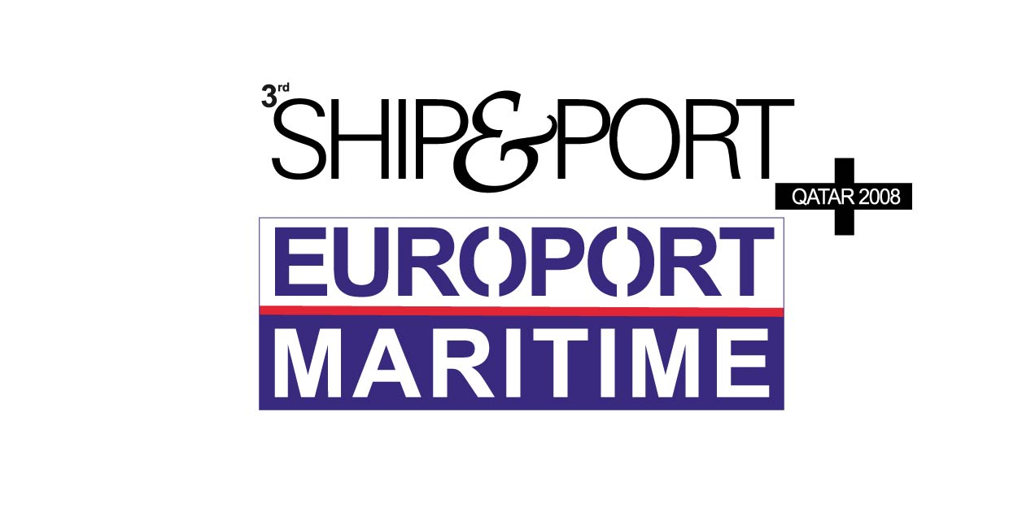

Logos of sponsors (QP, Naqilat) and supporting organisations

Early booking discount: For bookings received before 1st April 2008, when 4 delegates book from the same organisation, a 5th can attend for free.

www.cedaconferences.org/qatar2008

The Conference

This first CEDA international conference on dredging in the Arabian Gulf places special emphasis on providing a practical international and national forum for issues and ideas related to dredging.

Dredging associated with the creation of new land, port development and navigational improvement is essential to the construction and maintenance of a large part of the infrastructure on which our economic prosperity depends. The impressive developments along the Arabian Gulf Coast, particularly in the last five years, are testament to this.

Undertaking dredging projects in sympathy with the marine environment, whether they be large scale reclamation works or navigation channel improvements, present a range of challenges and demand smart approaches and novel solutions both from developers and the dredging industry alike. In view of the foreseen increased demand for reclaimed land in all parts of the world, together with improved understanding of the marine environment, the exchange of information and sharing of experience regarding these challenges and solutions is paramount to the successful delivery of ongoing and future dredging projects.

In line with its core mission “generation and dissemination of knowledge”, the Central Dredging Association (CEDA), an international professional association, will present a conference on dredging and land reclamation on 6th - 7th May 2008 in conjunction with the Ship & Port + Europort Maritime Exhibition.

The two day conference and technical visit will give a comprehensive overview of the latest developments and innovations of the various technical issues relevant to dredging and land reclamation works.

Themes will include:
- Design aspects (hydraulic, geotechnical)
- Environmental, regulatory aspects
- Dredging for land
- Dredging for energy (pipelines, offshore rigs)
- Dredging for port development

The presentations will be given by invited speakers representing a broad range of expertise and with extensive experience in the Gulf region.

In addition to the formal presentations, there will be plenty of opportunities for informal discussions and networking.

Who should attend
The conference is aimed at:
- practitioners and scientists representing project owners
- commissioners of large-scale dredging and reclamation projects
- professionals from port, coastal and environmental authorities
- dredging contractors
- consultants
- research institutes

Pre-Conference: Monday, 5th May

Opportunity to visit the Exhibition.

Conference Day 1: Tuesday, 6th May

0830 Registration, refreshment and dredging exhibition

0930 Opening: Rewert Wurpts, President CEDA

0935 Welcome address: Sheikh Hamad bin Suhaim al Thani, Minister of State, Government of Qatar

0945 Opening keynote: CEO Qatar Petroleum

1015 Coffee

Session 1: General Design

1045 Hydraulic aspects of waterfront development
Karsten Mangor, Dr Ida Brøker and Ian Sehested Hansen, DHI Water, Environment, Health, Denmark
1115 Sediment plumes from dredging and reclamation activities – the application of expert assessment and modelling tools
Dr Mike Dearnaley, Dr Jez Spearman and Michael Costaras, HR Wallingford, United Kingdom
1145 Geotechnical specifications – a delicate balance between desirability and availability
Art Nooy van der Kolff, Royal Boskalis Westminster, The Netherlands

1215 Lunch and opportunity to visit the Exhibition

Session 2: Environmental Issues

1315 Challenges for dredging and reclamation projects in the Arabian Gulf
Dr. Abdulaziz M Al-Suwailem and Dr Zenon Batang, King Fahd University of Petroleum & Minerals, King Fahd University, Saudi Arabia
1345 The environmental aspects of the Melbourne Channel Deepening Project
Jeff Baselmans, Port of Melbourne, Australia
1445 Building with nature
Prof. Dr. ir. Huib J. de Vriend, Ecoshape, The Netherlands

1445 Coffee

Session 3: Dredging Technology

1515 Recent developments on cutter suction dredgers for the Gulf area
Marcel Boor, IHC Merwede, The Netherlands
1545 Development of cutting systems for the Gulf region
Klaas Wijma, VOSTA LMG, The Netherlands
1615 Dredging rock with a trailing suction hopper dredge
Simon Burgmans, Van Oord Dredging & Marine Contractors and Prof. Dr. ir. Cees van Rhee, Dredging Engineering, Delft University of Technology, The Netherlands

1645 Close of Conference Day 1
Opportunity to visit the Exhibition

1800 Gala Dinner

Conference Day 2: Wednesday, 7th May

0800 Refreshment

Session 4: Case Studies

0900 Mega reclamations: Challenges for dredging and reclamation
Arnoud Kuis, Van Oord, The Netherlands
0930 The realisation of the Ras Laffan port expansion project. The clients’ perspective
Speaker from Qatar Petroleum, Qatar
1000 The realisation of the Ras Laffan port expansion project – The contractor’s perspective
Gert Blom, Project Director “Ras Laffan”, Boskalis Westminster Middle-East, Qatar

1030 Coffee

Session 5: Case Studies (cont’d) and Closing Keynote

1100 Technical Challenges of the Marine and Reclamation Works at The Pearl, Qatar
Hedwig Vanlishout, Project Director Marine Works “The Pearl Qatar”, Middle East Dredging Company (MEDCO), Qatar
1130 Dredging for energy
Noël Pille, Jan De Nul, Belgium
1200 Closing Keynote: Where to obtain dredging and reclamation guidance advice
Nick Bray, Dredging Research, United Kingdom

1230 Close of Conference

1245 Lunch

1345 Technical visit (details below) or opportunity to visit the Exhibition

1800 Conference Closing Reception

Please note: The organisers reserve the right to adjust or change the programme as necessary. A final programme will be provided to each registrant upon arrival.

Technical visit: Pearl Qatar
Wednesday, 7th May, 1345 - 1800 hrs

Short description of project(s) and programme. ANNA TO COMPLETE WITH ASSISTANCE FROM PCO: 21/01

You must register for the tour in advance (please refer to the registration form). For security reasons, those registering for the site visit are requested to provide a copy of their passport no later than one week prior to the visit (30th April). tbc

The coach will depart from the Qatar International Exhibition Centre at 1345 hrs and will return to the Ritz Carlton hotel at approximately 1800. Please check the conference web site for up to date information.

Accompanying persons programme

City Tour followed by a visit to Camels and Arabian Horses Stables

Tuesday, 6th May, 0900 - 1700 hrs
In the morning an enchanting tour that allows you to explore the old and new faces of the capital city. The tour starts with a drive along the spectacular Corniche of Doha. Discover the local architecture, Dhow harbour and view the Ruling Palace, its clock tower, and futuristic skyscrapers. Our first stop will be at the camel, goat, and sheep markets where you will witness the tradition and heritage of these wonderful creatures, followed by a stop at the fish, vegetable, and fruit markets.

We will continue with a visit to the old souk, one of the most traditional areas in Doha where you can buy gold, spices, and local produce, as well as falcon shops that taking you to the heart of Qatar’s traditions.

After lunch in a local restaurant we will visit the Arabian horse stables and camel racetrack that lies 45 kms west of Doha, where thousands of camels are trained. Subject to approval, the tour may also include a visit to an Oryx farm.

The trip costs US$ 95 per person.
The tour will depart from The Ritz Carlton and will arrive back at the same place.

Post conference tour: Desert Safari
Thursday, 8th May, 1400 – 2100 hrs
A safari in this part of the world means an excursion into the desert. You will be picked up in a powerful 4WD, driven by an experienced driver, and taken off into the dunes for some thrilling off-roading and spectacular scenery.

The drive will take us across the sand to Khor AI Udeid (also known as the Inland Sea) near the Qatar, Saudi Arabia borders and back to our permanent camp in the desert located on sandy beaches. After we arrive at the camp, you can enjoy the view of the sand dunes and the beach; have a swim, a game of beach volleyball, go sand skiing or relax enjoying the tranquility of the view. All this while our professional chef prepares the BBQ meal including soft drinks and water. The camp is equipped with Bedouin style tents, carpeted and with traditional seating, sweet water for showers, and bathrooms.

We will depart from The Ritz Carlton Hotel and arrive back there.…

Ship & Port + EUROPORT MARITIME 2008
The CEDA conference is being held in association with Ship & Port + EUROPORT MARITIME 2008, a tailor made maritime exhibition for international manufacturers seeking a foray into one of the most promising markets of the Middle Eastern Region, Qatar.
The exhibition is organised by Ahoy Rotterdam, the organiser of the worlds leading biennial trade fair EUROPORT MARITIME in Rotterdam, the Netherlands in co-operation with Al Fajer, Dubai. The exhibition will be open to visitors on 5th – 7th May from 10am to 6pm daily. Delegates attending the CEDA conference will have free entry. Further details can be found at www.shipport.info.

Exhibition space
Anybody wishing to secure exhibition space at Ship & Port + EUROPORT MARITIME 2008 should contact Mr Jeen Joshua, jeen@alfajer.net, or for more information visit the exhibition web site at www.shipport.info.

Date and venue
The conference will be held on the 6th - 7th of May at the Qatar International Exhibition Centre, Doha, Qatar (www.qiec.com.qa)

Conference language
English.

Accommodation
A limited number of bedrooms have been reserved for conference participants in various hotels close to the conference venue. The dedicated conference hotel is The Ritz Carlton, Doha. The conference booking rate for a single/dounle room is US$ 302/day. The cut-off date for this rate is: CHECK WITH RAJUDIN. Please note that after this date the hotel can no longer guarantee the availability of rooms. A booking form for the Ritz Carlton Doha is available on the conference’s web site. Upon receipt of your booking, we will send you confirmation, along with a list of all hotels, their rates, contact details and distance from the conference venue. This information is also available on the conference’s website: www.cedaconferences.org/qatar2008

Delegate fees [in a text box highlighted]

Conference participant: US$ 1200.00
Partners Programme: US$ 95.00tbc
Post-conference tour: US$ 110.00

These fees include attendance at the conference, documentation and catering announced in the programme, gala dinner on 6th May, closing reception on 7th May, an optional site visit on 7th May, free entrance to the Ship & Port + Europort Maritime Exhibition and a copy of the official exhibition catalogue.

Practical information

Visa:
Nationals of the countries listed below can obtain a visa upon arrival at the Qatar International Airport. Passports should be valid for more than 6 months on arrival: United States of America Britain, France, Italy, Germany, Canada, Australia, New Zealand, Japan, Netherlands, Belgium, Luxembourg, Switzerland, Austria, Sweden, Norway, Denmark, Portugal, Ireland, Greece, Finland, Spain, Monaco, Vatican, Iceland, Andorra, San Marino, Liechtenstein, Brunei, Singapore, Malaysia, Hong Kong, and South Korea.

Those countries listed can obtain a 1 month tourist visa on arrival at Doha International Airport. The cost of the visa will be US $28.00 per person per passport, which has to be paid at Doha Airport upon arrival.

The cost of the tourist visa is non-refundable. Payment can be made at any of the immigration desks at the arrival hall of Doha International Airport with the following credit card; Vis; Visa Electron; MasterCard; Maestro and E-Cash (a pre-paid credit card that can be bought in the arrival lounge with cash).

Please note cash payments in local (Qatari Riyals) or other currencies are not accepted.

Regarding the instant visa forms, these are available at the immigration passport control counters at the Doha International Airport. Passengers should ask the authorities to provide them with the instant visa form. These forms need to be duly filled in and afterwards together with their credit card or E-Cash card they should proceed to the immigration passport control counters, where they should submit the following documents:
- Original passport
- Credit card or E-Cash card
- Instant visa form filled in for each passport holder

For countries not listed above, a tourist visa should be pre-arranged by sending clear copies of passport, stating the exact arrival and departure dates and flight details to your local embassy or consulate at least three weeks prior to arrival. The cost of the visa is US $80.00 per visa.

Payment for visas must be made in advance and this payment is non-refundable. Issuance of the visa is purely at the discretion of the Immigration Authorities in Qatar and we shall not be responsible for rejection or non issuance of visa.

For further visa information, please visit www.e.gov.qa.

On request, the organisers will be pleased to send a personal invitation to prospective participants of the conference after the registration fee has been received. Such invitations can only be issued for the purpose of assisting participants to raise travel funds or obtain visas. No financial commitment on the part of the organisers is implied. Please indicate on the conference registration form if you wish to receive a letter of invitation.

Arrival in Qatar:
When travelling to your hotel from the airport, we would strongly recommend you to book a car through the hotel you are staying at. Transfers costs approximately $40. For further information about Qatar, please visit www.qatarinfo.net, the official web site of the Foreign Information Agency of the State of Qatar.

Organisation
The CEDA conference and exhibition on dredging and land reclamation is organised by Al Fajer Information and Services and Ahoy Rotterdam and under auspices of the Central Dredging Association (CEDA). Event Logistics Ltd has been appointed as the Conference Secretariat.

About CEDA
The Central Dredging Association (CEDA) is an international professional membership organisation for all those involved in dredging related activities and who live or work in Europe, Africa, or the Middle East. CEDA provides an independent forum for the exchange of knowledge in fields related to dredging, maritime construction and dredged material management. Members are drawn from many fields and include consultants, research and educational institutes, port authorities, government agencies, dredging contractors, builders of dredging vessels, and suppliers of ancillary equipment. CEDA encompasses a wide range of disciplines and activities and does not represent the interests of any particular industry sector. CEDA’s aims are:

- To promote the education and instruction of its members and others concerned with dredging and related activities
- To generate and disseminate reliable, quality information on dredging and associated activities
- To develop or contribute to the development of guidelines relating to good practice and environmental protection and enhancement
- To stimulate the initiation of, and/or to support, research relevant to dredging activities
- To be pro-active in providing expertise in relevant policy-making activities
- To enhance the public understanding of dredging and recognition of its contribution to society

Organising Committee
Anna Csiti, CEDA
Jeen Joshua, Al Fajer Information and Services
Peter Niematsverdriet, Ahoy Rotterdam
Raymond Silikaus, Ahoy Rotterdam
Richard Hart, Event Logistics Ltd

Technical Papers Committee
Abdulaziz M. Al-Suwailem, King Fahd University, Saudi Arabia
Ida Broker, DHI, Denmark
Michael Costaras, HR Wallingford, UK
Anna Csiti, CEDA, the Netherlands
Bernard Malherbe, Jan De Nul, Belgium
Hendrik Postma, Royal Boskalis Westminster, the Netherlands
Cees van Rhee, Delft University of Technology, the Netherlands
Tiedo Vellinga, Port of Rotterdam, the Netherlands
Wim Vlasblom, the Netherlands (Chairman)

Conference Secretariat - Enquiries
Richard Hart
Event Logistics Ltd
Lawn Cottage
Owl Street
Stocklinch
Ilminster TA19 9JW
UK

T: +44 (0) 1460 259776
F: +44 (0) 1460 258783
E: info@event-logistics.co.uk

Conference website: www.cedaconferences.org/qatar2008

Conference Registration Form

Dredging and Sustainability: How wide is the Gulf?
6th - 7th May 2008

Qatar International Exhibition Centre, Doha, Qatar

WAYS TO REGISTER

- Book online at www.cedaconferences/qatar2008
- Email copy of booking form to info@event-logistics.co.uk
- Fax this completed registration form to +44 (0) 1460 258783
- Post to Event Logistics Ltd.,
Lawn Cottage, Owl Street, Stocklinch, Ilminster TA19 9JW, UK

DELEGATE DETAILS; Title, First Name, Family Name, Job Title, Organisation, Address Lines, Postcode, Country, Tel, Fax, Email (note that email is required as all joining instructions to be sent out by email)

ACCOMPANYING PERSON’s DETAILS; Title, First Name, Family Name

□ Please tick if you require a letter of invitation for VISA purposes

Profession: □ Project Owner □ Consultant □ Researcher
□ Dredging Contractor □ Academia □ Student

DELEGATE FEES

□ US Dollars - $1200
(If you are booking before the 1st April 2008, remember the early booking discount, when 4 delegates book from the same organisation, a 5th can attend for free.)

These fees include attendance at the conference, documentation and catering announced in the programme, gala dinner on 6th May, closing reception on 7th May, an optional site visit on 7th May, free entrance to the Ship & Port + Europort Maritime Exhibition and a copy of the official exhibition catalogue.

Important: All the events below are included in the delegate fee. Please tick the events you would like to attend, any items you have not ticked, we will assume that you will not be attending:

□ Tuesday 6th May – Gala Dinner
□ Wednesday 7th May – Technical Visit to Pearl Qatar
(In order to attend the technical visit, please include a copy of your passport with your registration form.)
□ Wednesday 7th May – Conference Closing Reception

Additional Excursions

□ Tuesday 6th May – Partners Programme – $95.00tbc

□ Thursday 8th May – Post Conference Desert Safari – $110.00

Payment Details

Cheque
Please make cheques payable to Al Fajer Information and Services Dubai.

I enclose a cheque for $_________

Credit/Debit Card

Please debit my MasterCard / Visa / American Express / Switch / Delta card by

$_________

Card number
Card Expiry Date
Card Issue Date (debit cards only)
Security Number
Cardholder Name
Cardholder Billing Address (if different from address previously given)
Signature (I authorise use of my credit card for the above payment. I have read and agreed with the terms and conditions.)

Bank Transfer
Tick box (I confirm that payment has been arranged by bank transfer.)

If paying by this method, please include an additional $20 to cover the bank charges.

Bank Account Details
HSBC Bank (Middle East)
Dubai Main Branch,
P.O. Box 66, Dubai, U.A.E.
Account No. 020-581880-002
Swift Code: BBMEAEAD
Account Name: Al Fajer Information and Services

Data Protection
Event Logistics and CEDA are committed to protecting your privacy and security. The information provided by you will be used for correspondence, billing and accounts for this event. The data will also be held on a database to provide you with information on services that CEDA provide in the dredging field. We do not sell data information to third parties. If you do not wish to receive details of future CEDA products and services, please tick here.

From time to time we may invite you to supply personal information in order for us to provide you with services. By submitting your personal information, you consent to such processing in connection with such orders, offers or services and for any other purposes to which you consent at the time you provide the information. We will never wilfully disclose personal information about you to any third party, other than to process an order, without first receiving your permission or unless we are under a legal obligation to do so.

Terms and conditions

Booking Conditions
A confirmation will be sent to you on receipt of your booking. If you have requested a payment receipt, one will be sent to you from Event Logistics Ltd. Payment must be received before the conference date. If payment is not received, delegates will be asked to guarantee payment with a personal credit card.

Joining Instructions
Joining instructions will be issued subject to receipt of payment. We cannot be held responsible for the non-arrival of registration information. If you have not heard from us within 14 days of the conference date, please contact Event Logistics Ltd.

Cancellations / Substitutions
Cancellations and substitutions must be made in writing. Cancellations made four weeks before the event will be charged at £75 +VAT. Cancellations made between four weeks and two weeks will be charged at 50% of the invoice total. Cancellations made after this period will be charged at the full invoice amount. However, you can send a substitute delegate at any time. Bookings received less than two weeks before the conference date can only be paid by credit card. Cancellations and substitutions must be made in writing. Non-attendance at the event will be considered a late cancellation and the full fee will be payable.

It may be necessary for reasons beyond the control of the organisers to alter the content and timing of the programme, or the identity of the speakers. In the event that the conference has to be cancelled, you will be entitled to a full refund of your delegate fee. The organisers will not be responsible for the reimbursement of any other costs incurred by potential delegates.

Special Arrangements
If you have any additional requirements, such as wheelchair access or special dietary needs, please let us know in advance.

General
Nothing in these terms and conditions shall restrict or exclude any liability that we have to any party that cannot be excluded by law. These Terms and Conditions shall be governed by English Law, and the courts of England and Wales shall have exclusive jurisdiction over any disputes arising.

Submission of this booking constitutes a legally binding agreement.

Liability and Insurance
Registration fees do not include insurance of any kind. It is strongly recommended that when registering for the conference and booking travel arrangements, intending participants should arrange personal insurance cover for the following:

- loss of registration and tour fees, deposits, hotel costs, and air fares, through cancellation of the Congress for Force Majeure or any other reason
- failure to utilise pre-booked arrangements due to airline delays for Force Majeure or any other reason
- medical expenses and loss or damage to personal property

Neither CEDA, nor Al Fajer information and Services, Ahoy Rotterdam and Event Logistics Ltd will accept responsibility for any personal injury, damage or loss of property, which may occur in connection with the conference. The insurance is to be purchased in the participant's own country.

